What is Virtual Machines?

Virtual machine, commonly shortened to just VM, is no different than any other physical computer like a laptop, smart phone, or server. It has a CPU, memory, disks to store your files, and can connect to the internet if needed.

VMs are often thought of as virtual computers or software-defined computers within physical servers, existing only as code.

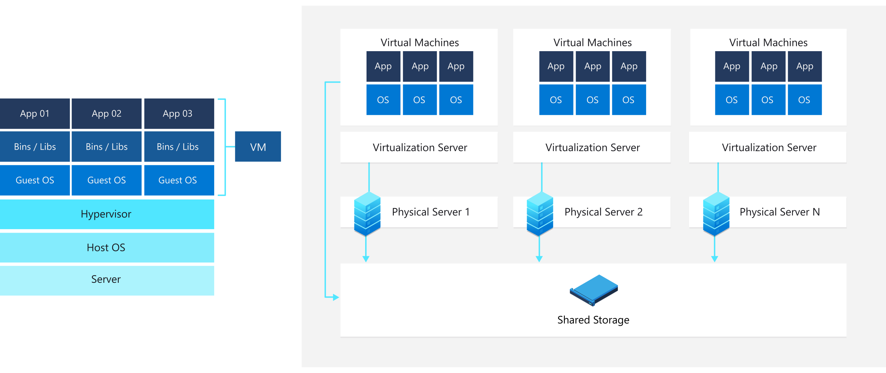

How does Virtual Machine works?

A virtual machine is a computer file, typically called an image, that behaves like an actual computer. It can run in a window as a separate computing environment, often to run a different operating system or even to function as the user's entire computer experience as is common on many people's work computers.

The virtual machine is partitioned from the rest of the system, meaning that the software inside a VM can't interfere with the host computer's primary operating system.

--------------------------------------------------------------------------------------

Next I have Installed the Virtual Box and also the Ubuntu via virtual box